42) Şimdi konvolüsyon işlemini Custom IP de gerçekleştirmeyi deneyeceğim.

<https://www.xilinx.com/video/hardware/creating-an-axi-peripheral-in-vivado.html>

İlk olarak 3x3 konvolüsyonu gerçekleyecek bir devre tasarladım. Bunun için bir Vivado projesi oluşturdum ve VHDL kodlarını yazdım.

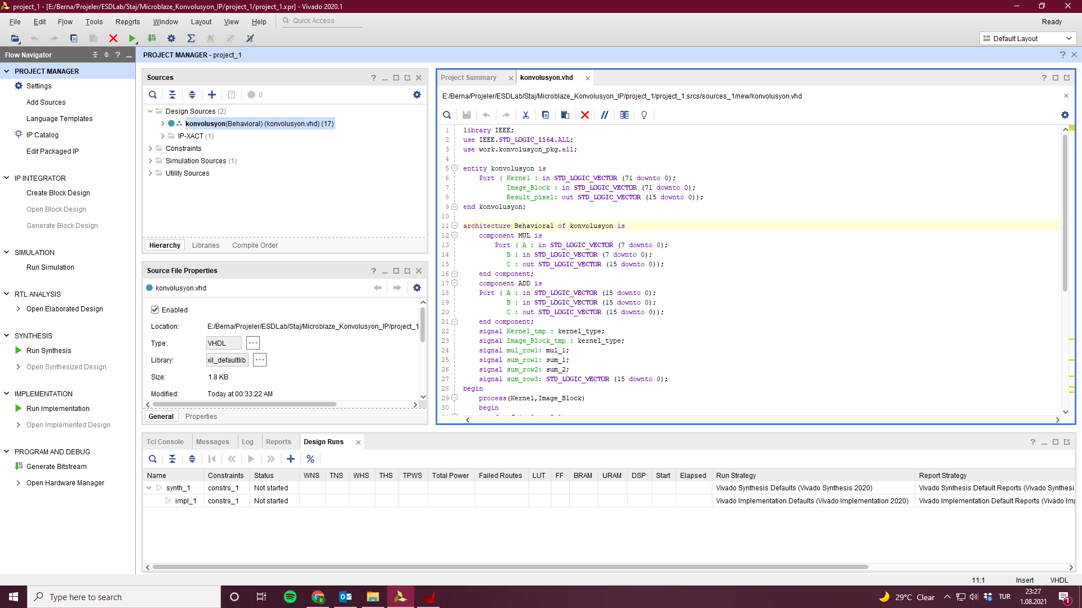

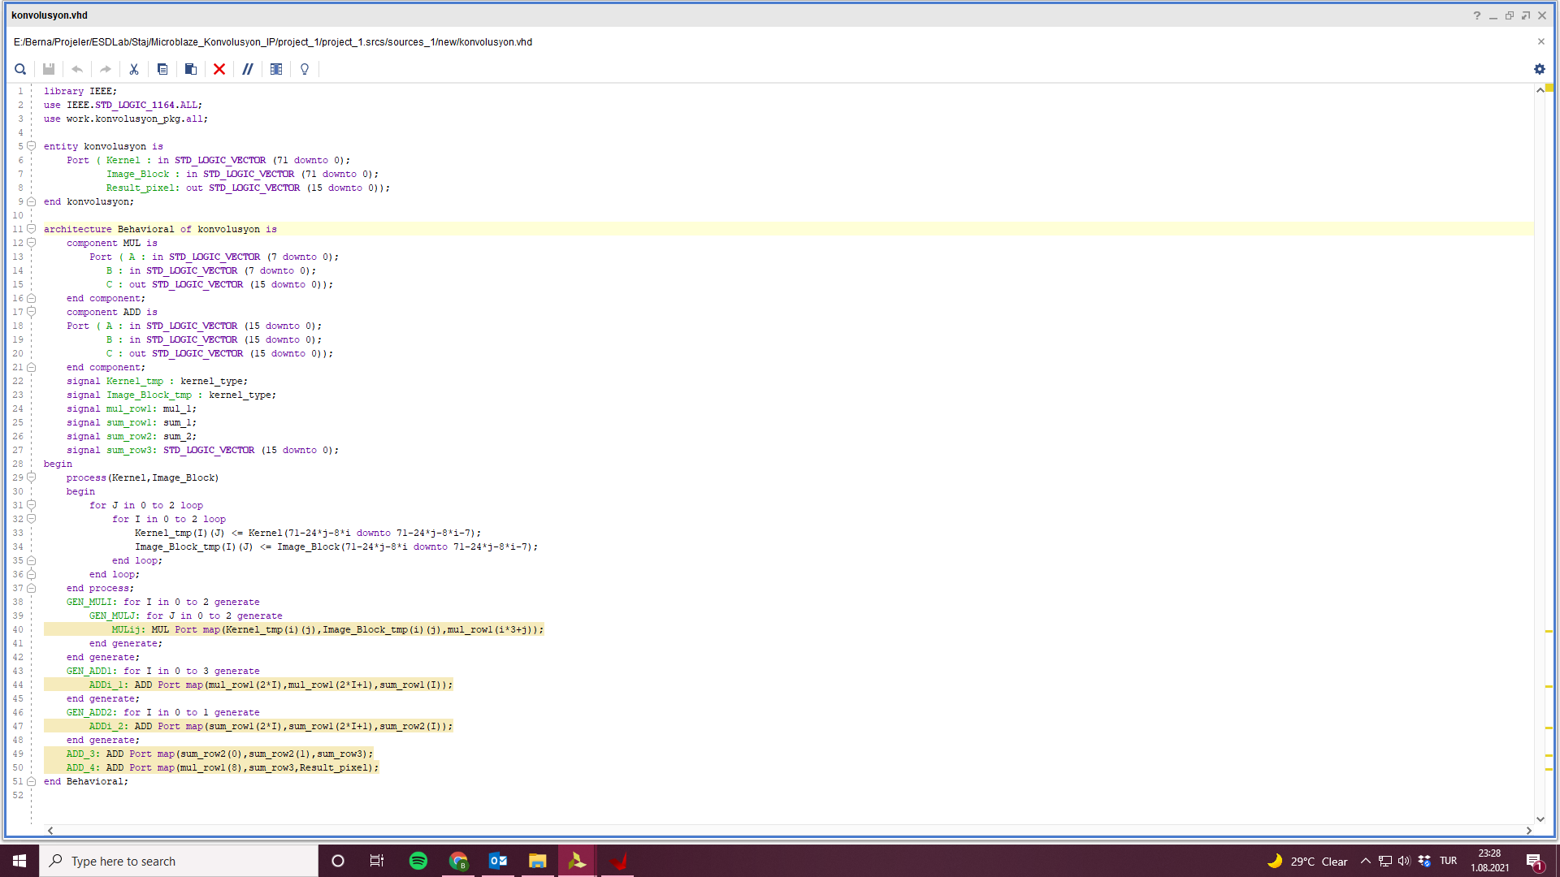

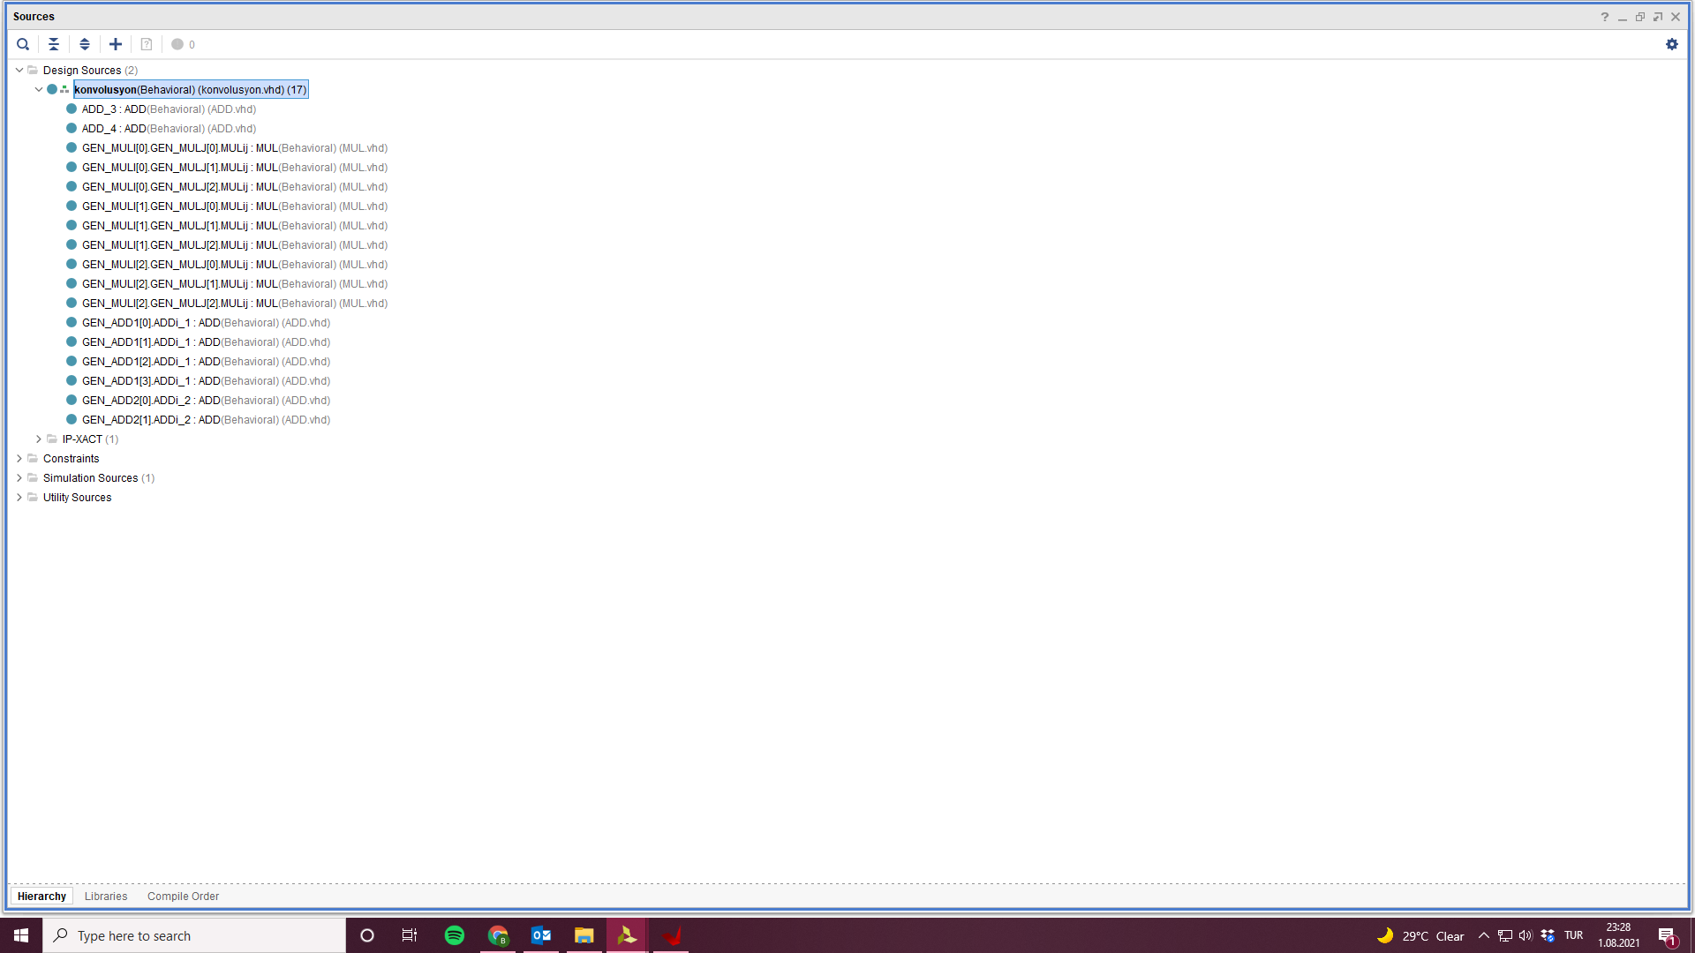

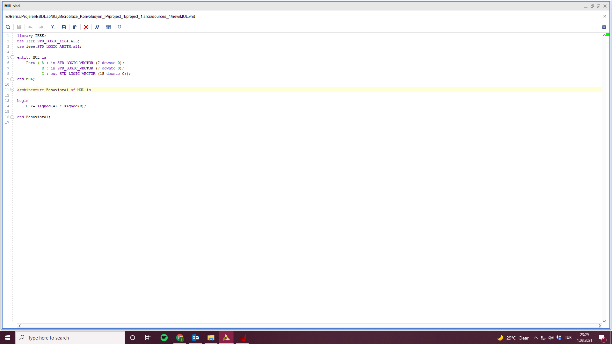

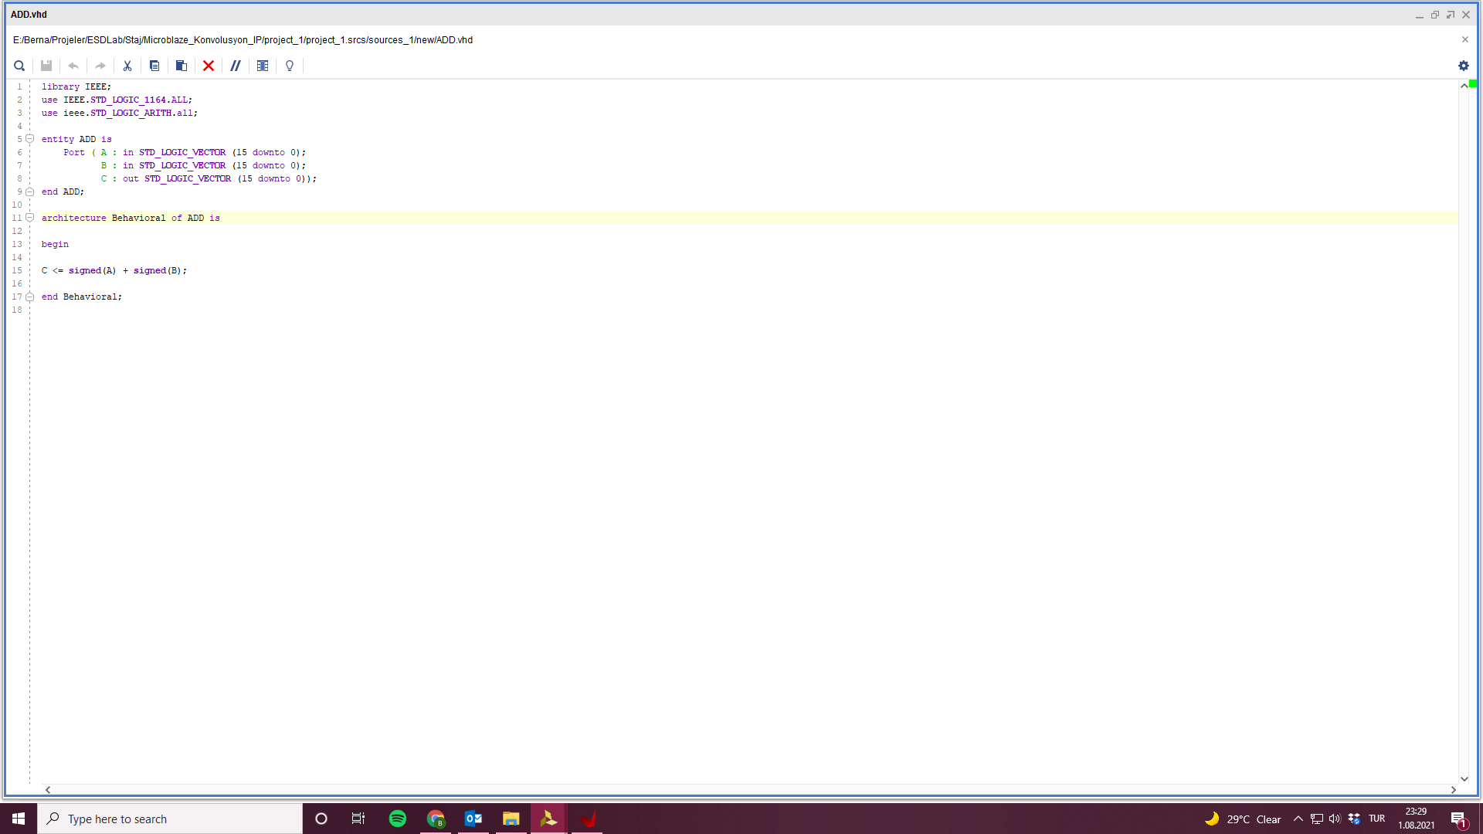

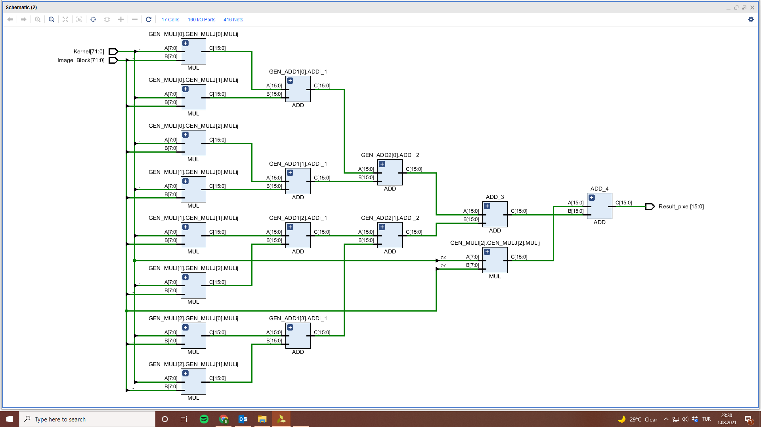

43) Create and Package New IP

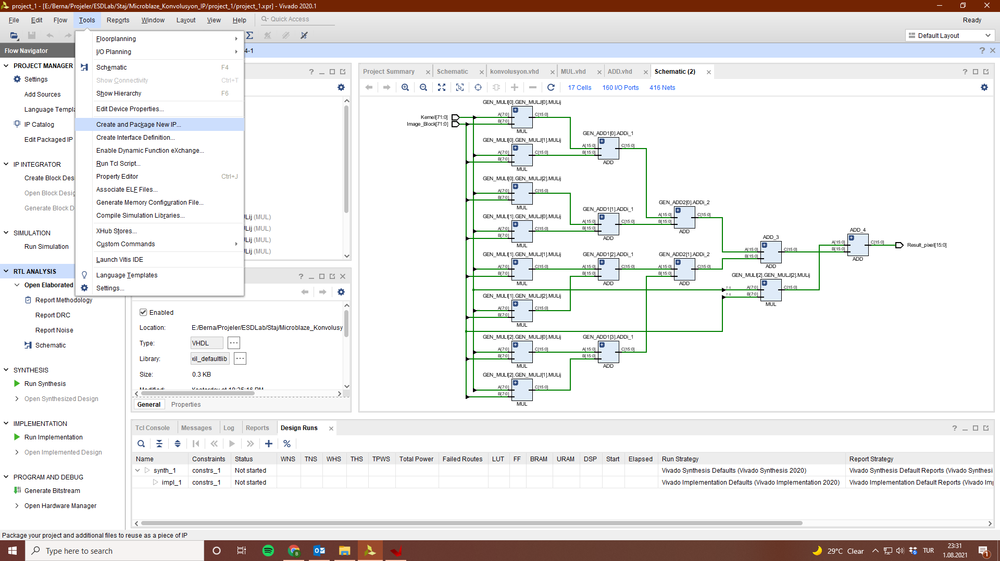

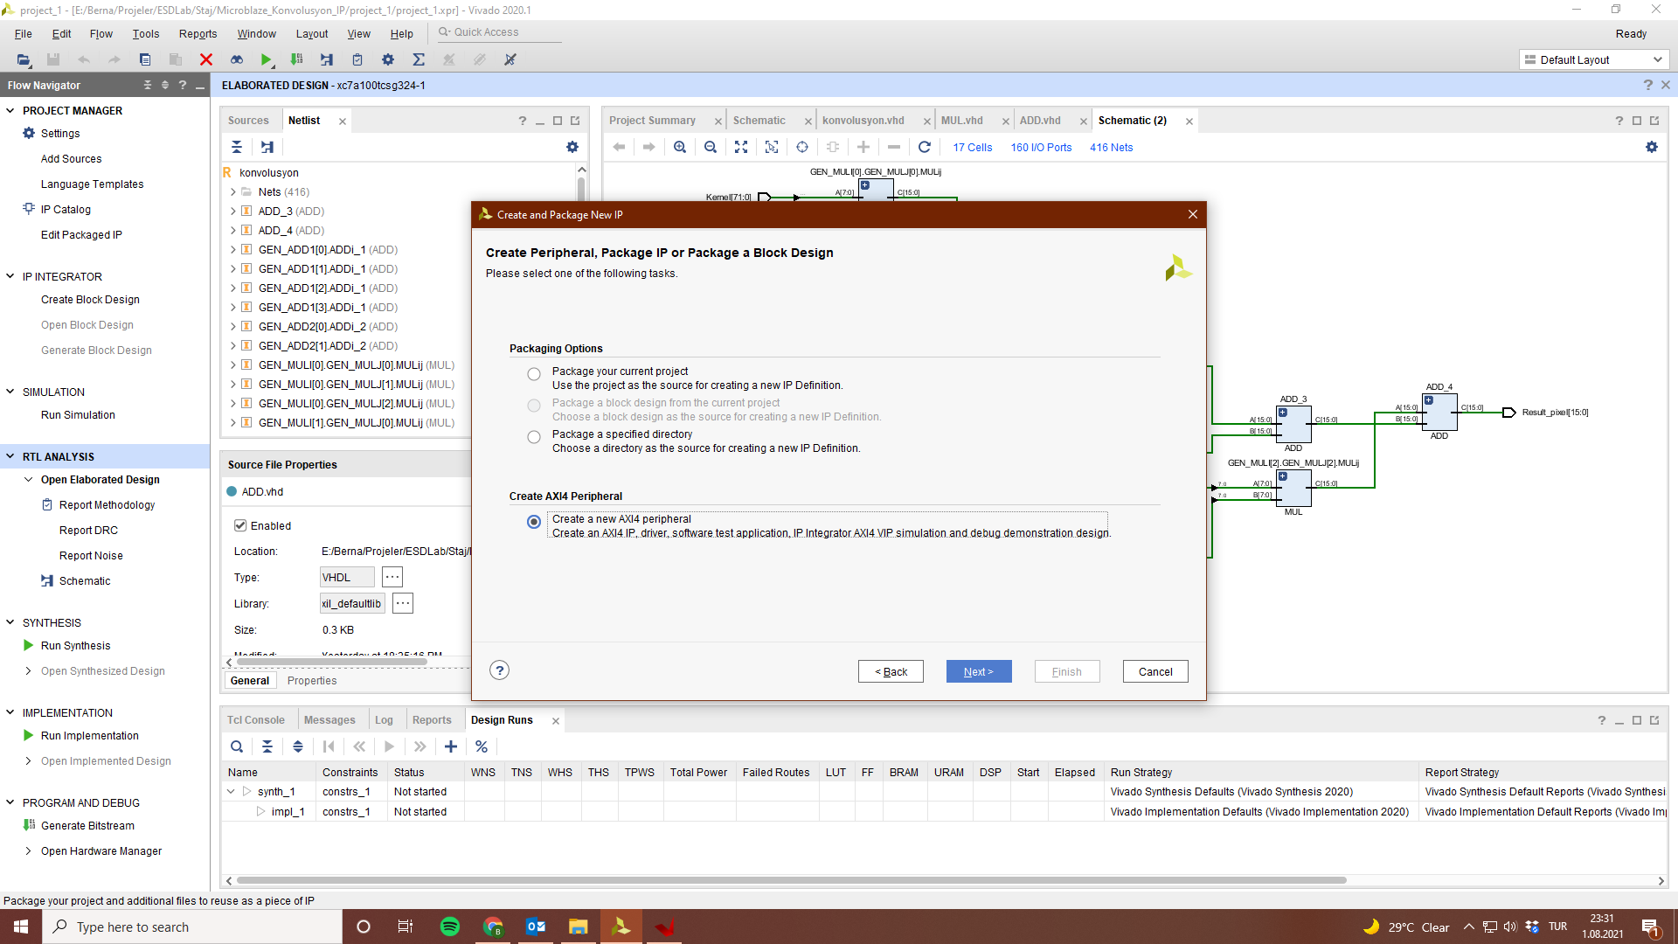

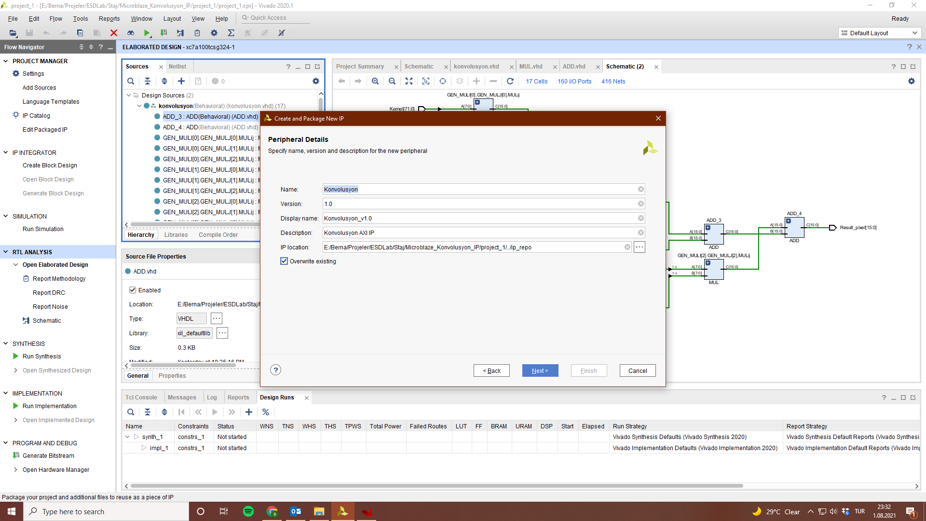

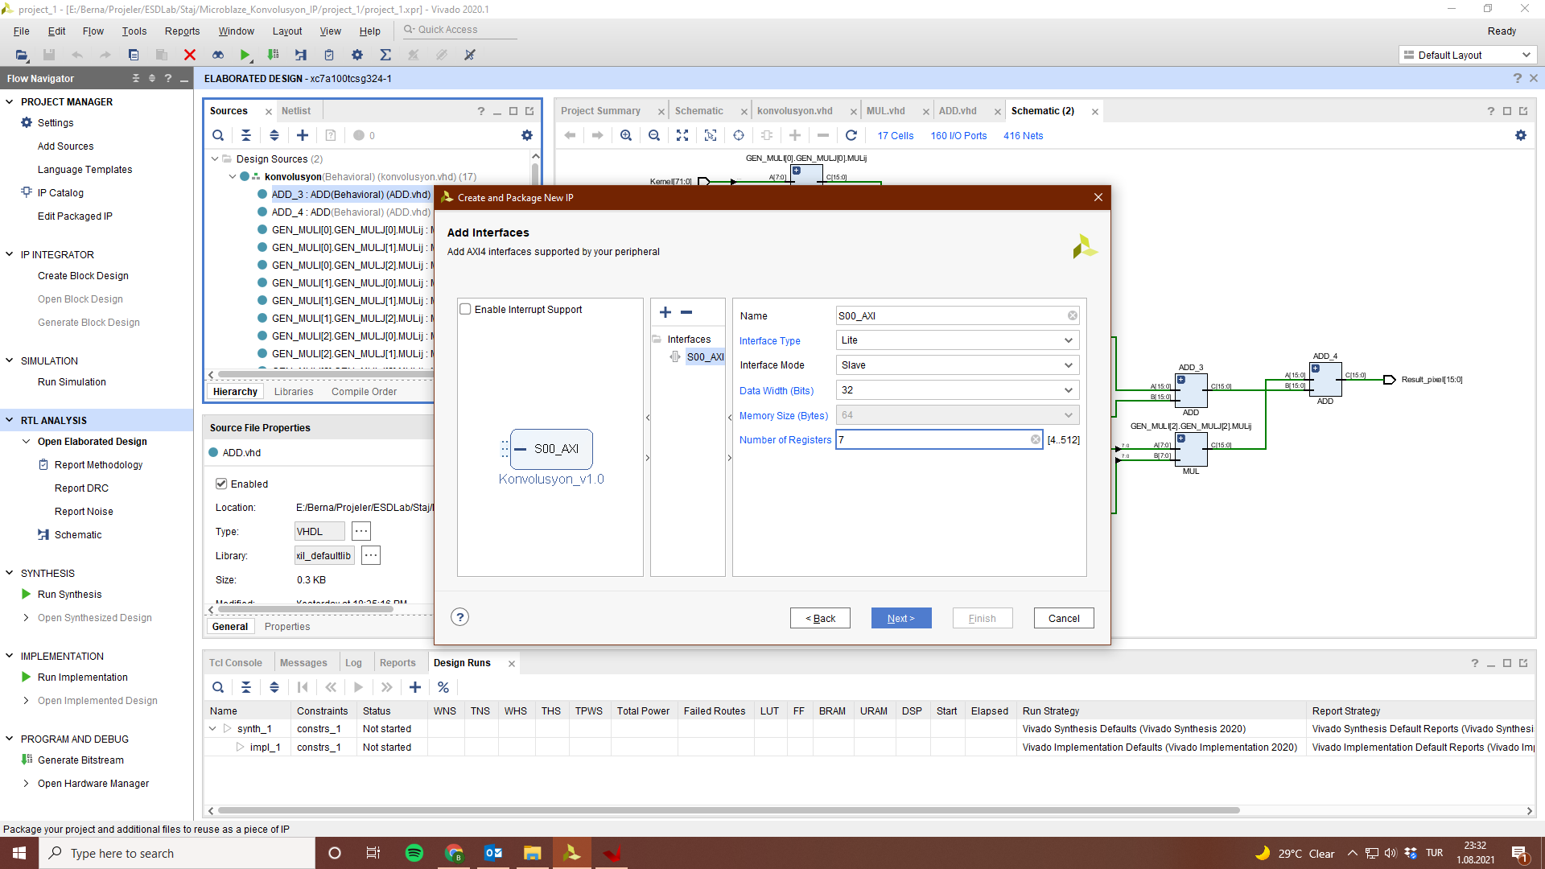

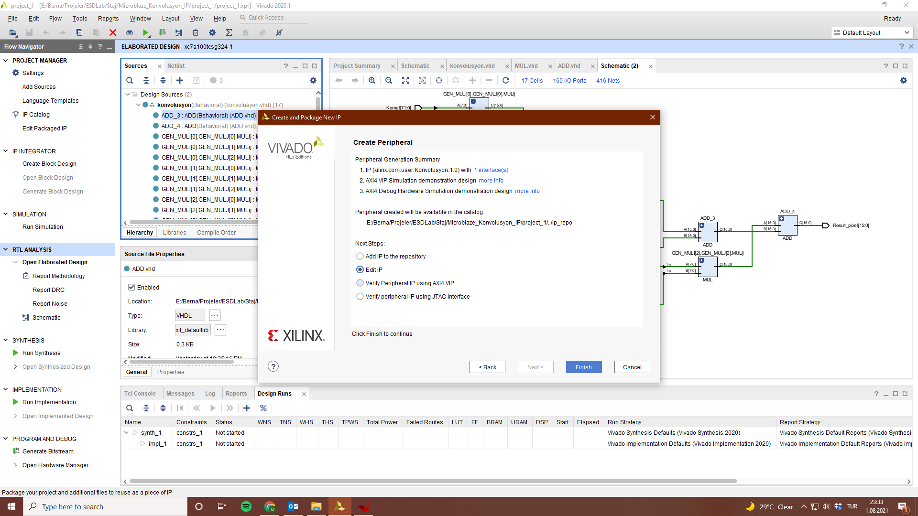

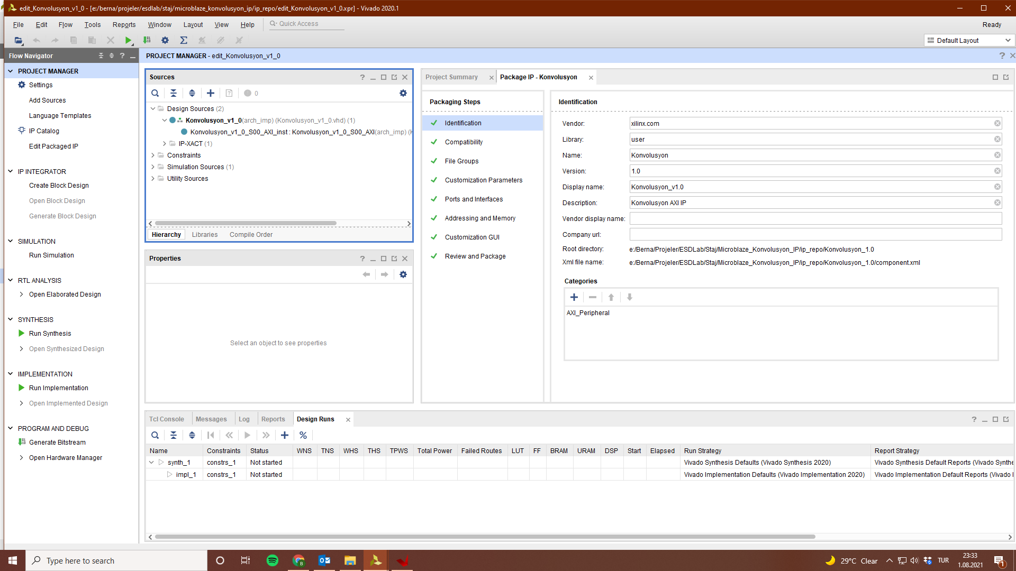

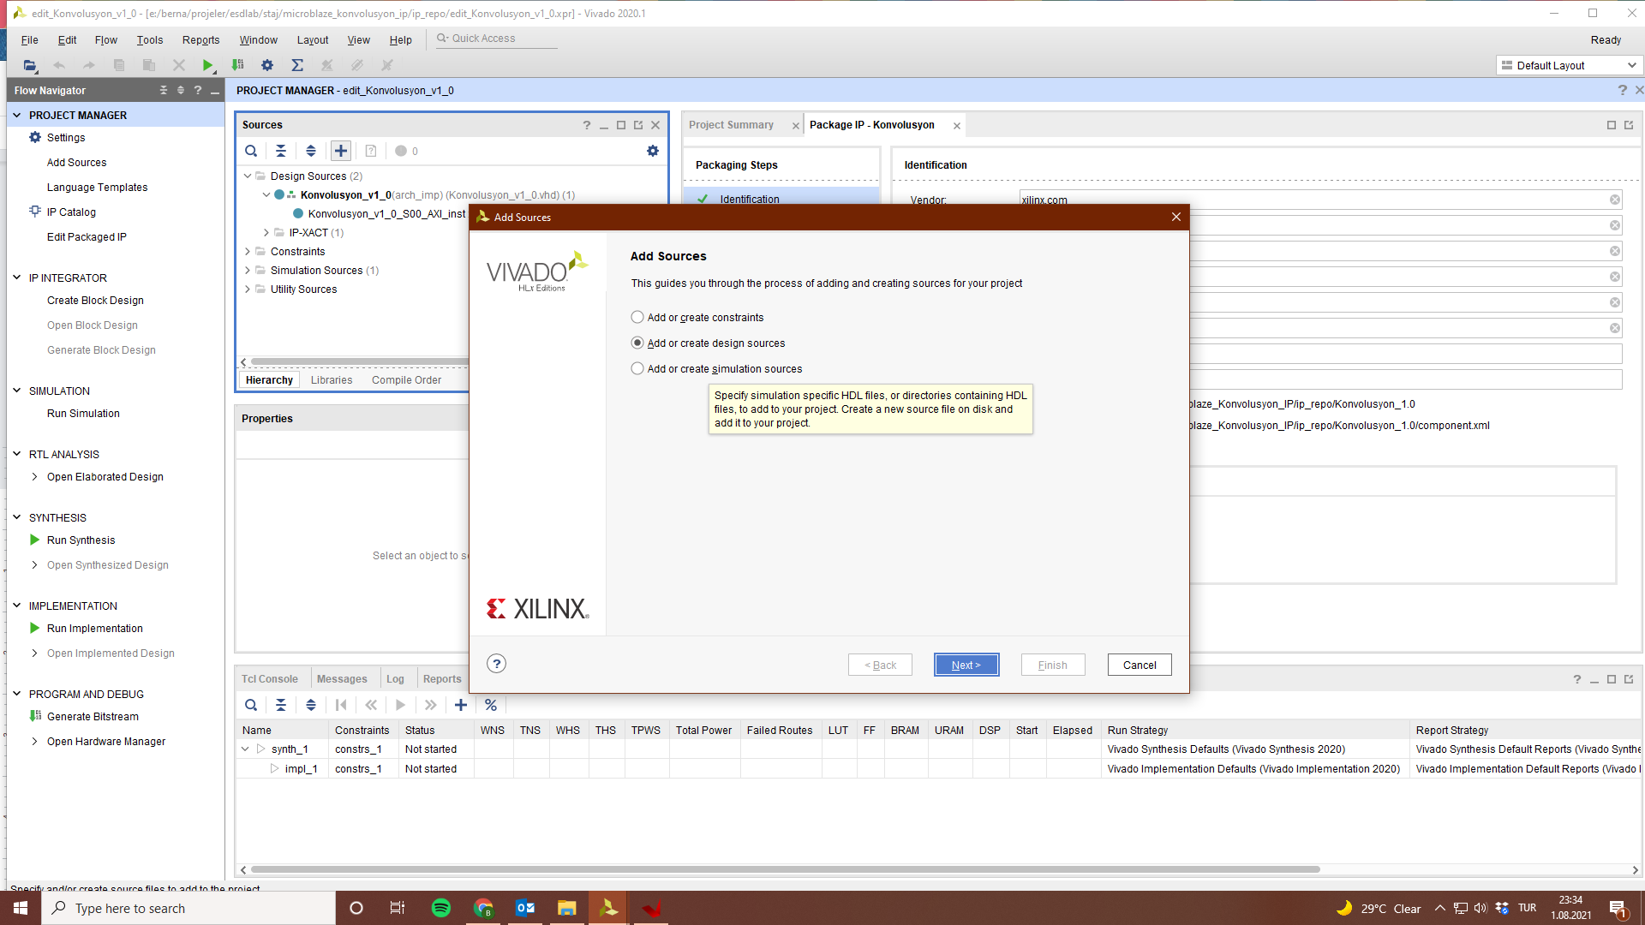

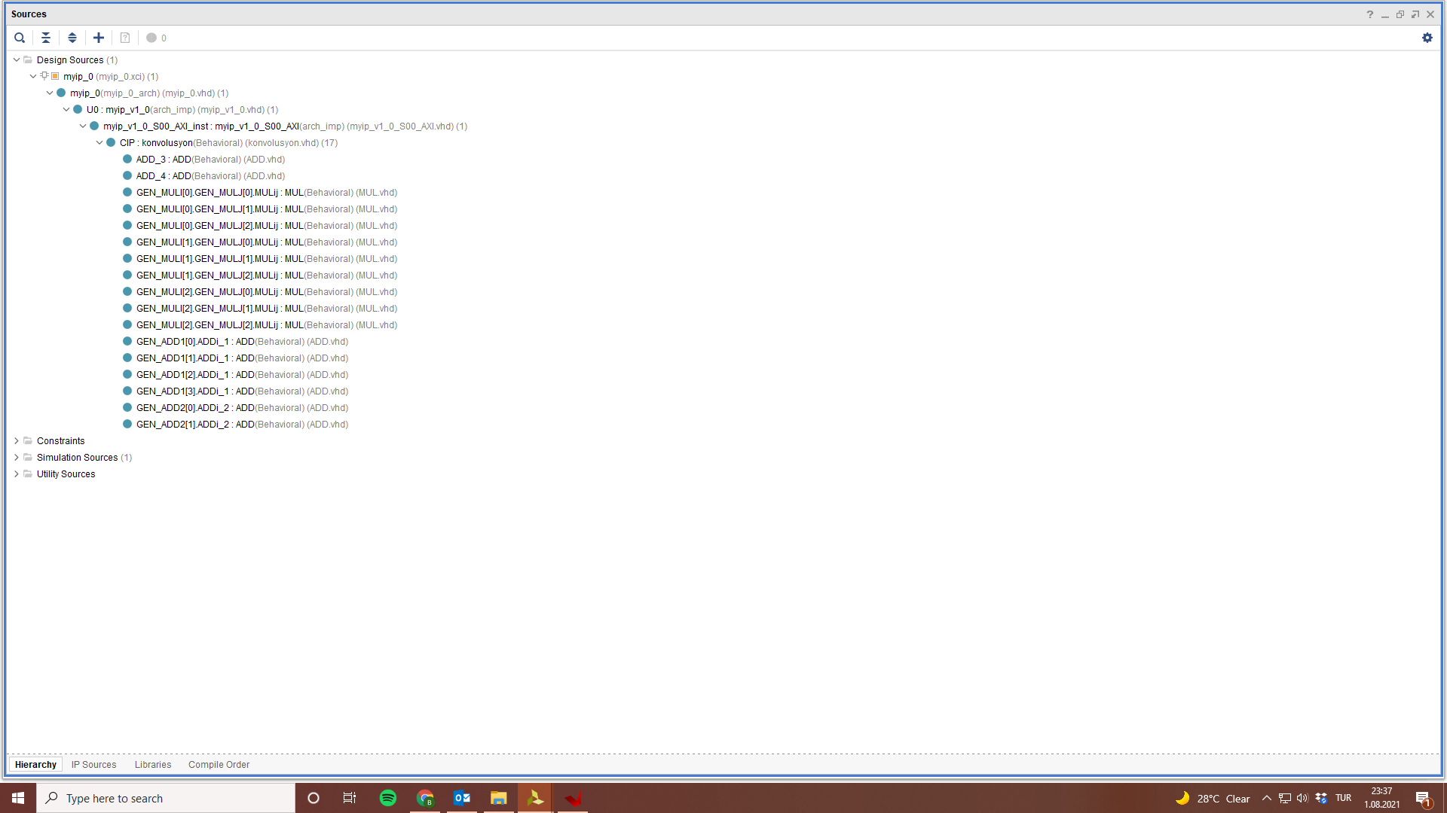

44) AXI bağlantısını tanımlayan dosyanın içine konvolusyon bloğunu koyun.

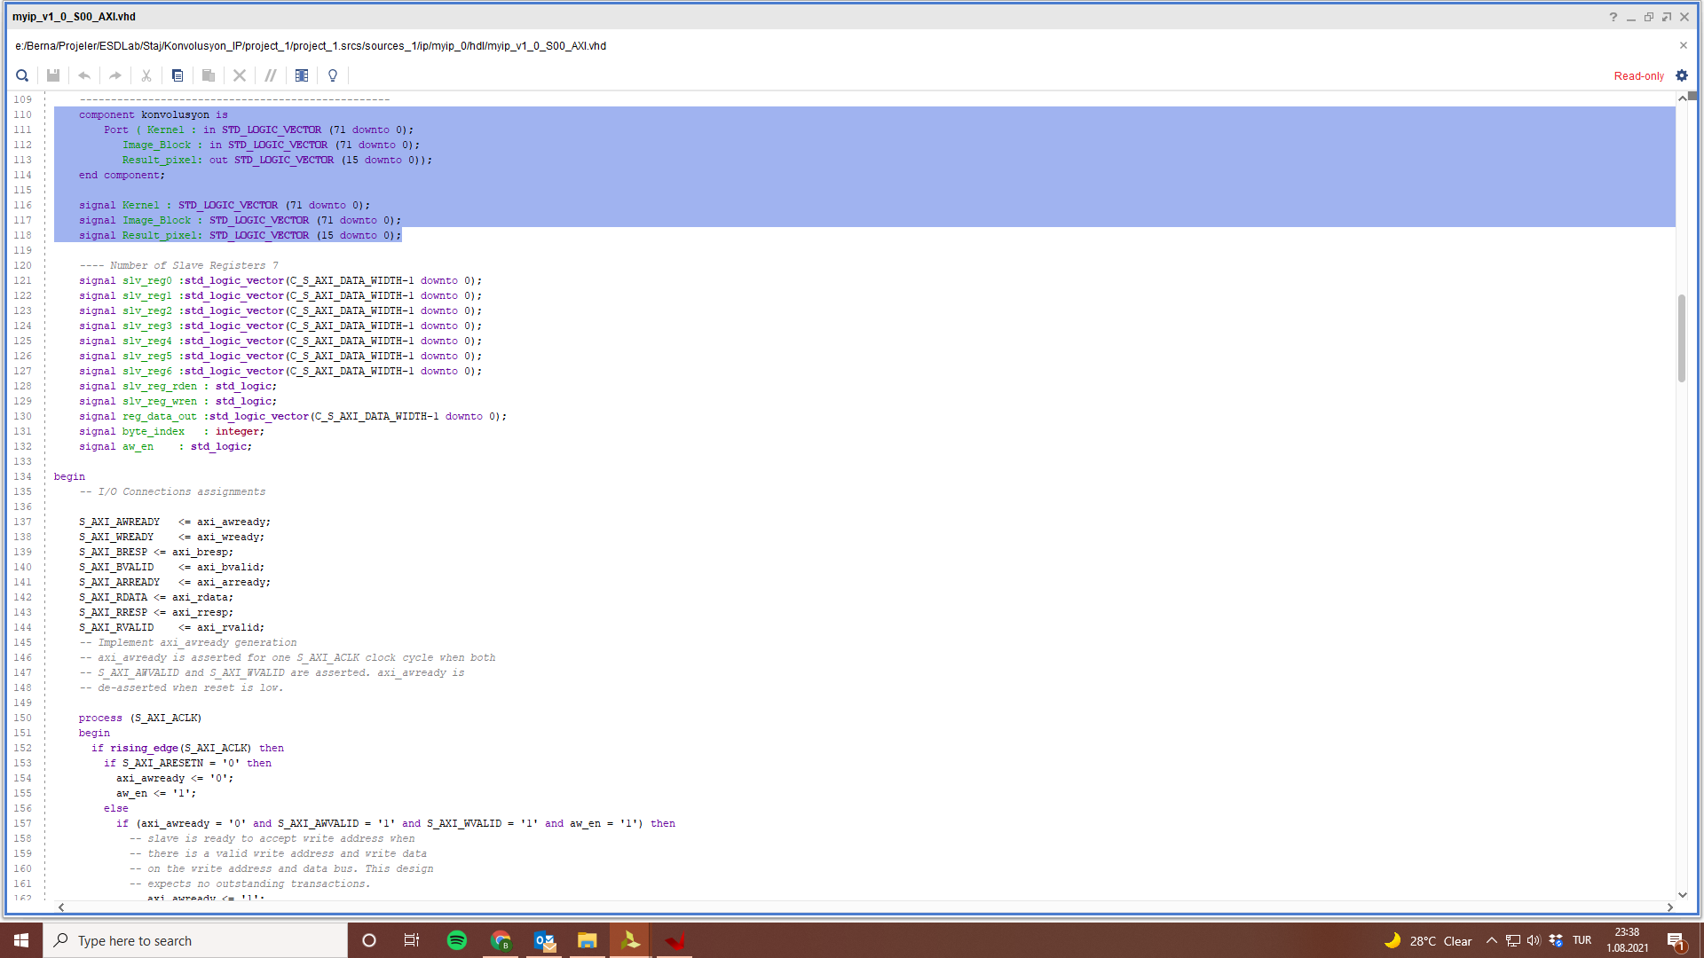

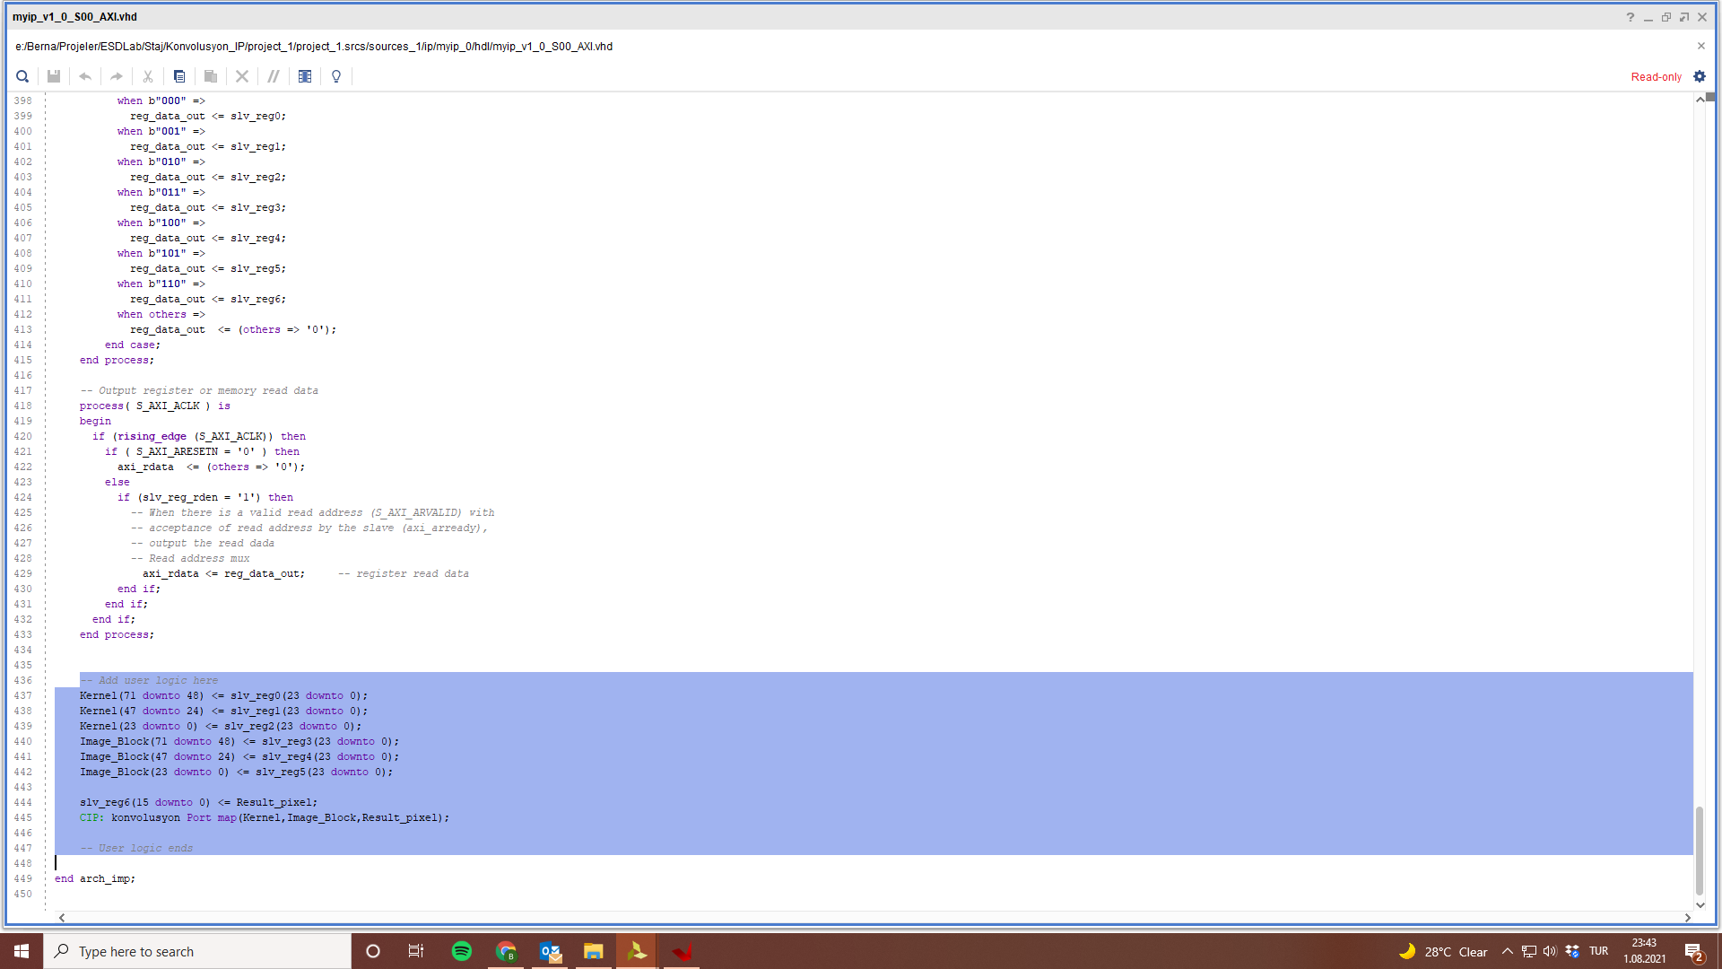

45) Yeni bir Microblaze projesi oluşturup konvolusyon IP sini ekleyelim.

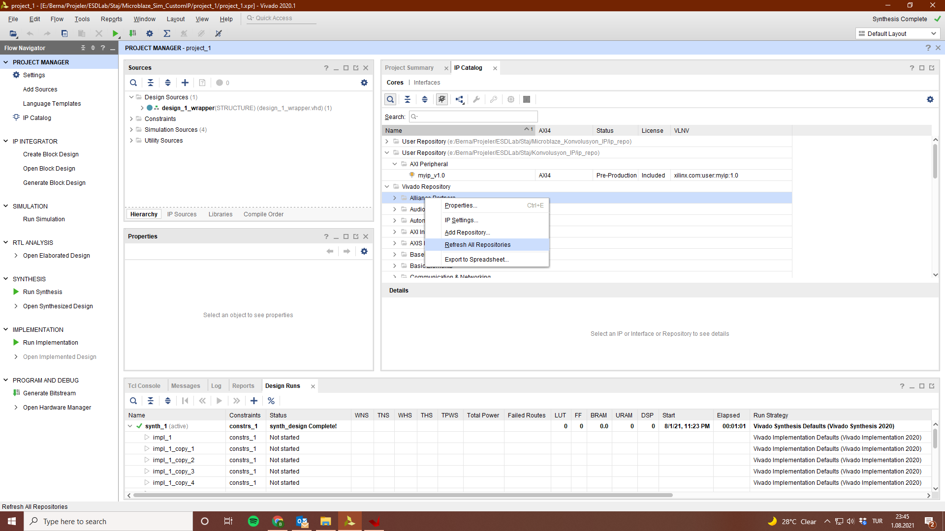

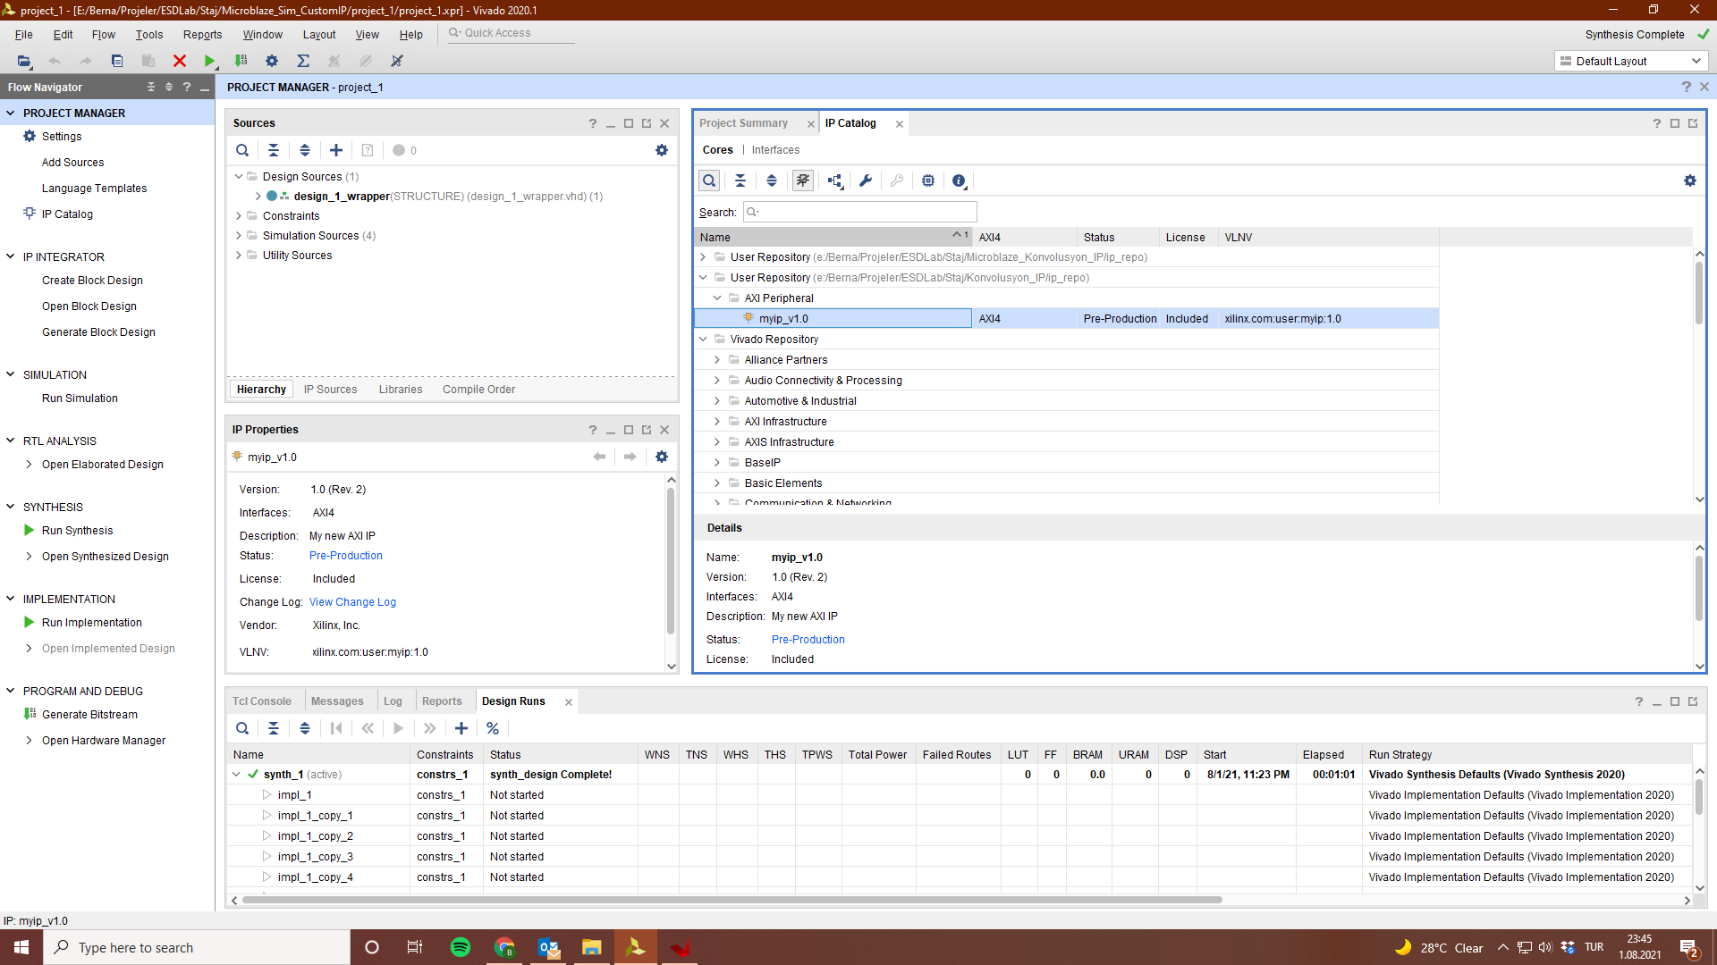

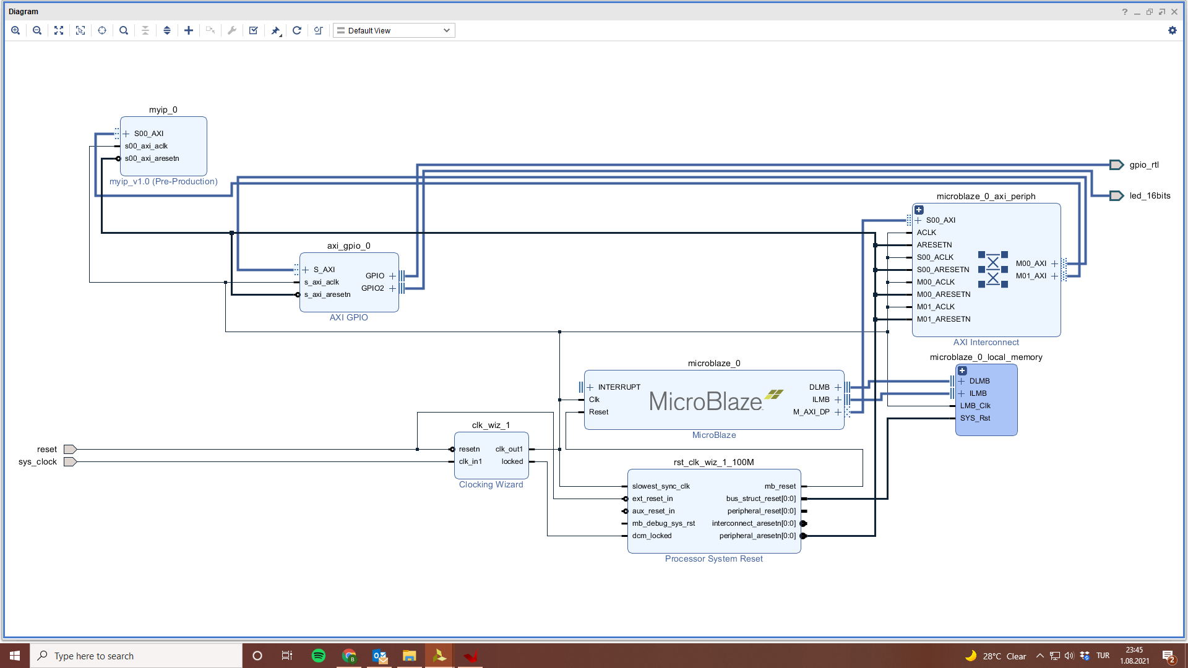

46) Create HDL wrapper, synthesis, export hardware, launch vitis

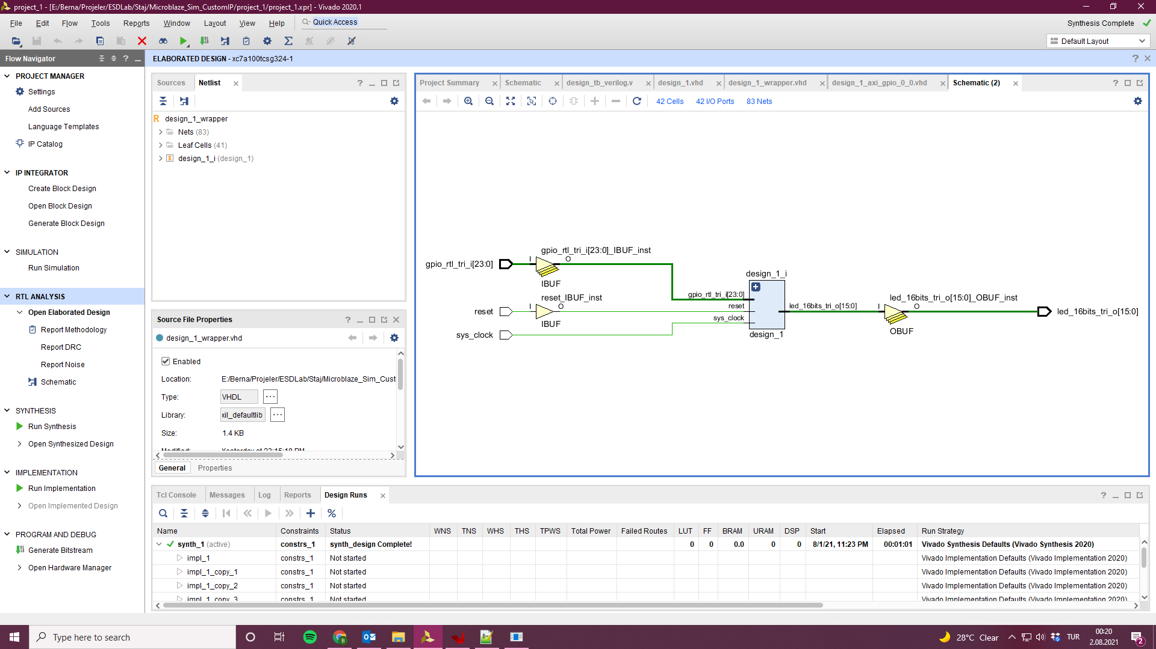

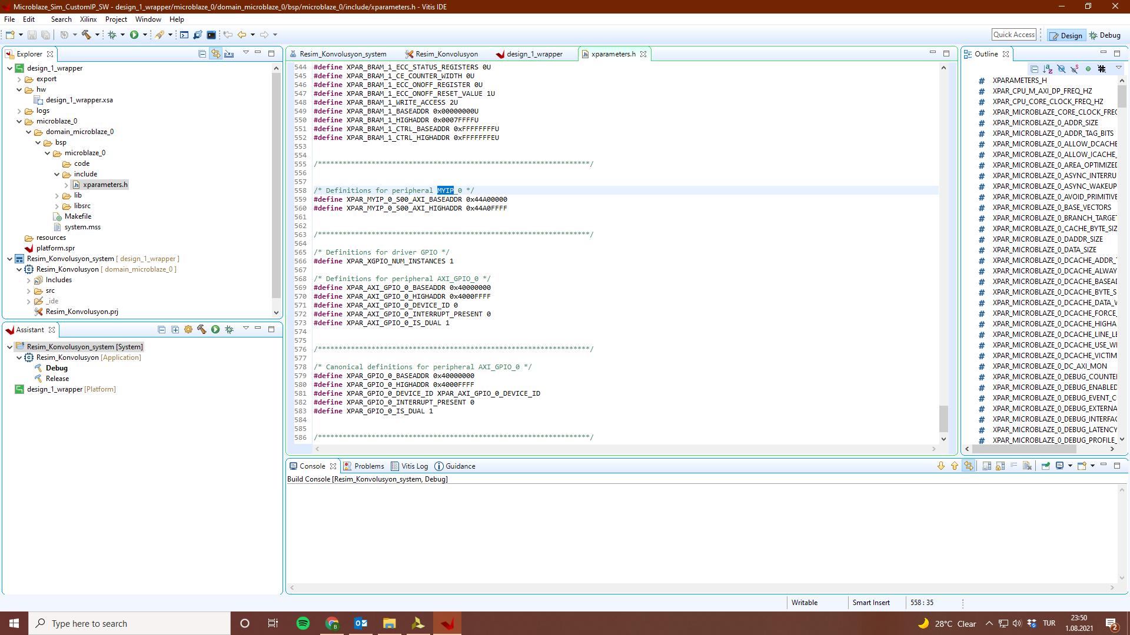

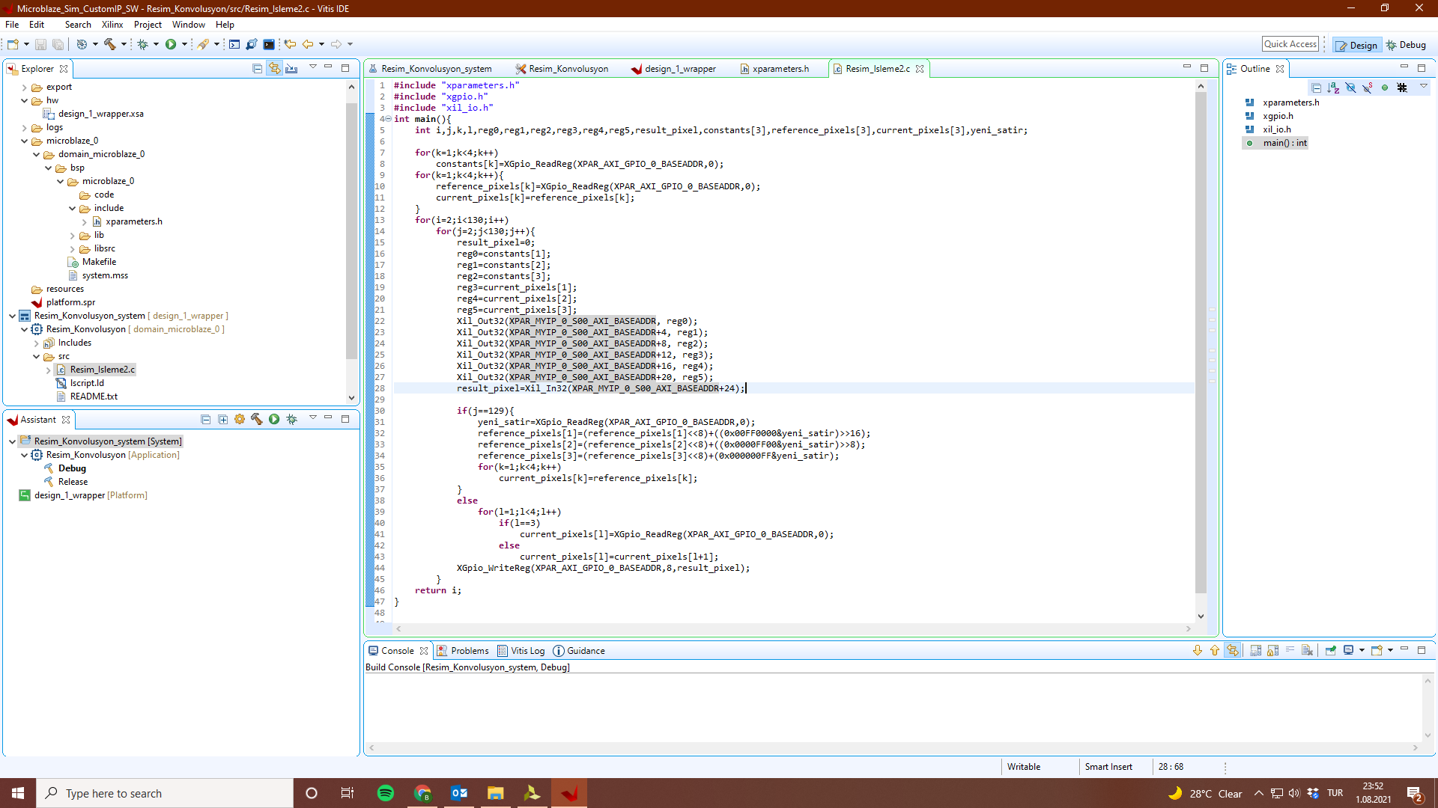

47) Testbench yazın.

`timescale 10ns / 1ns

module design_tb_verilog;

reg [23:0] gpio_rtl_tri_i;

wire [15:0] led_16bits_tri_o;

reg reset;

reg sys_clock = 0;

integer i,j,k,l;

integer fin_pointer,fout_pointer;

reg [7:0] input_image[1:130][1:130];

design_1_wrapper UUT (.gpio_rtl_tri_i(gpio_rtl_tri_i),.led_16bits_tri_o(led_16bits_tri_o),.reset(reset),.sys_clock(sys_clock));

always #5 sys_clock = ~sys_clock;

initial

begin

fin_pointer= $fopen("input_image.txt","r");

for(i=1;i<131;i=i+1) begin

for(j=1;j<131;j=j+1) begin

$fscanf(fin_pointer,"%d\n",input_image[i][j]);

end

end

$fclose(fin_pointer);

fout_pointer= $fopen("output_image.txt","w");

reset = 0;

# 10;

reset = 1;

//filter constants are being written

gpio_rtl_tri_i[23:16] = 1;

gpio_rtl_tri_i[15:8] = 2;

gpio_rtl_tri_i[7:0] = 1;

@(posedge UUT.design_1_i.axi_gpio_0.U0.ip2bus_rdack_i);

gpio_rtl_tri_i[23:16] = 2;

gpio_rtl_tri_i[15:8] = 4;

gpio_rtl_tri_i[7:0] = 2;

@(posedge UUT.design_1_i.axi_gpio_0.U0.ip2bus_rdack_i);

gpio_rtl_tri_i[23:16] = 1;

gpio_rtl_tri_i[15:8] = 2;

gpio_rtl_tri_i[7:0] = 1;

@(posedge UUT.design_1_i.axi_gpio_0.U0.ip2bus_rdack_i);

for(l=-1;l<2;l=l+1) begin

gpio_rtl_tri_i[23:16] = input_image[2-1][2+l];

gpio_rtl_tri_i[15:8] = input_image[2][2+l];

gpio_rtl_tri_i[7:0] = input_image[2+1][2+l];

@(posedge UUT.design_1_i.axi_gpio_0.U0.ip2bus_rdack_i);

end

for(i=2;i<130;i=i+1)

for(j=2;j<130;j=j+1) begin

if(j==129) begin

gpio_rtl_tri_i[23:16] = input_image[i+2][2-1];

gpio_rtl_tri_i[15:8] = input_image[i+2][2];

gpio_rtl_tri_i[7:0] = input_image[i+2][2+1];

@(posedge UUT.design_1_i.axi_gpio_0.U0.ip2bus_rdack_i);

end else begin

gpio_rtl_tri_i[23:16] = input_image[i-1][j+2];

gpio_rtl_tri_i[15:8] = input_image[i][j+2];

gpio_rtl_tri_i[7:0] = input_image[i+1][j+2];

@(posedge UUT.design_1_i.axi_gpio_0.U0.ip2bus_rdack_i);

end

@(posedge UUT.design_1_i.axi_gpio_0.U0.ip2bus_wrack_i);

$fdisplay(fout_pointer,"%d",led_16bits_tri_o/16);

end

$fclose(fout_pointer);

$finish();

end

endmodule

48) *.elf dosyası eklenecek. Associate elf file

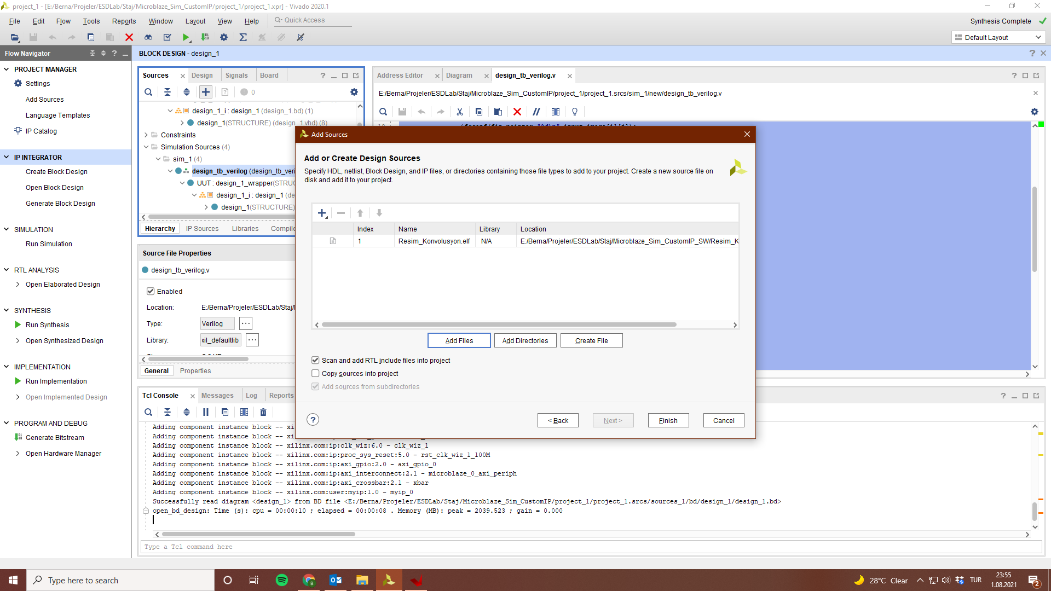

49) Simulation